**Spreadsheet**

**Class Six**

**Lab 21**

|  |
| --- |
| Lab Objectives:  * Opening Google Sheet |

# What is Spreadsheet?

## an electronic document in which data is arranged in the rows and columns of a grid and can be manipulated and used in calculations

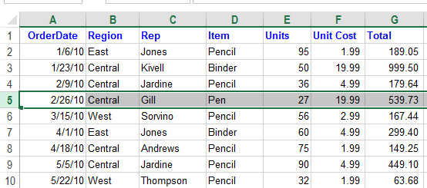

# Spreadsheet Software

## Today, Microsoft Excel is the most popular and widely used spreadsheet program, but there are also many alternatives. Most popular Spreadsheet software are:

## Microsoft Excel

## Google Sheets

## WPS Spreadsheets

## Libre Office Calc

## EtherCalc

In this course we will use Google Sheet to learn about Spreadsheet.

# What is Google Sheets?

## Google Sheets is a free, cloud-based spreadsheet application. That means you open it in your browser window like a regular web page, but you have all the functionality of a full spreadsheet application.

# Getting Started with Google Sheet

## If this is your first time with Sheets, head over to [https://www.google.com/sheets/about/](https://www.google.com/sheets/about/" \t "/home/deepto/Documents\\x/_blank) which looks like this:

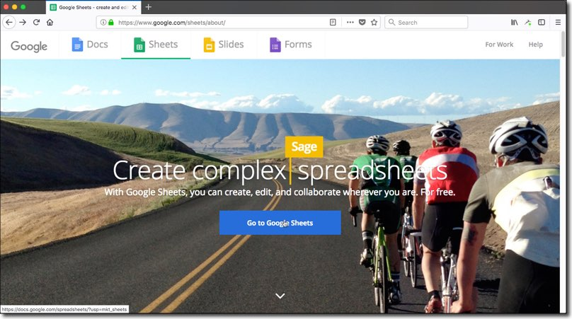

## Click on the Go To Google Sheets button in the middle of the screen. You’ll be prompted to login:

## IMG_256

## And then you arrive at the Google Sheets home screen, which will show any previous spreadsheets you’ve created.

## Click the huge green plus button to create a new Google Sheet:

## IMG_257

## Opening your first Google Sheet from Drive

## You can create new Google Sheets from your Drive folder by clicking on the blue NEW button:

## IMG_258

When you create a new Google Sheet, it’ll be created in your main Drive folder (your root folder):

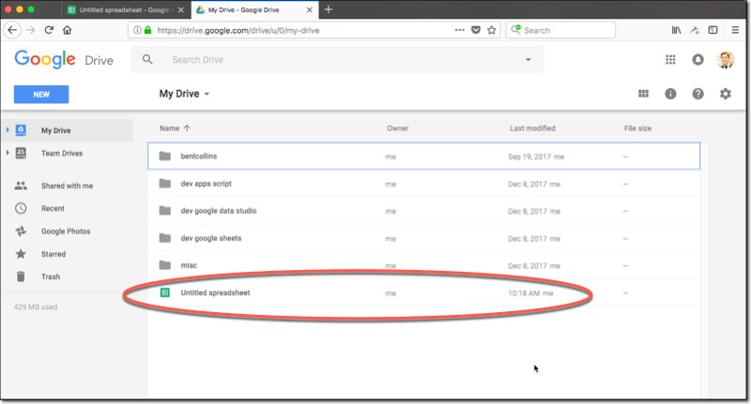

## (Note: Don’t panic if you don’t see the Sheet yet, it may not show up until you’ve renamed it. See next step on how to do this.)

## Here you can drag it to a different folder if you wish (to keep things organized). Do this by clicking-and-holding the file, and dragging to where you want it to go:

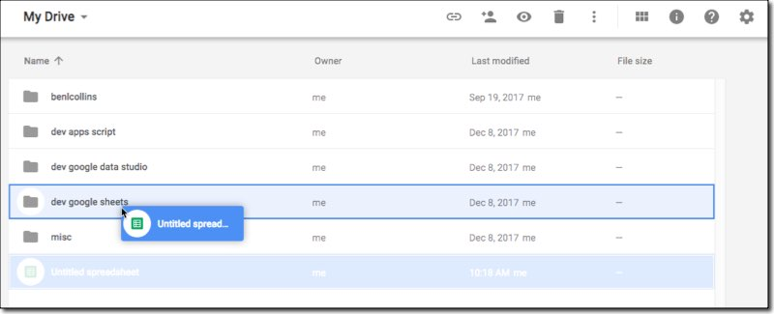

# The Google Sheet editing window

## This is what your blank Google Sheet will look like:

